Linux Commands Practical Steps (Updated)
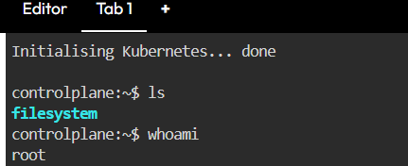
Step 1: whoami command shows the current logged-in user.
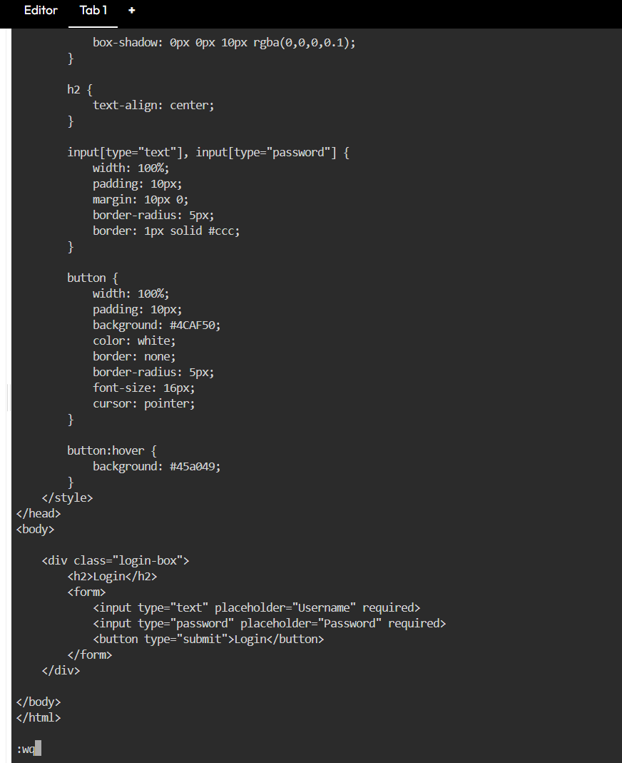
Step 2: vi commands and this is the code that added to login.html
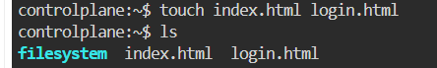
Step 3: ls command lists files in the directory.
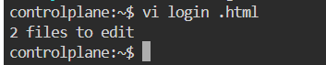
Step 4: vi command opens login.html file for editing.
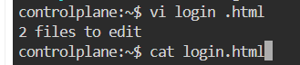
Step 5: cat command displays the content of login.html.
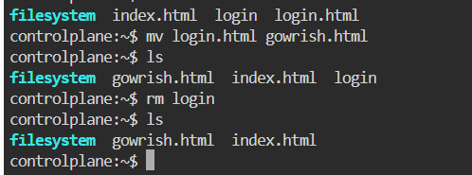
Step 6: mv command renames login.html to gowrish.html and rm deletes login file.
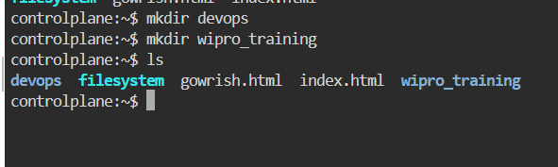
Step 7: mkdir command creates devops and wipro_training directories.
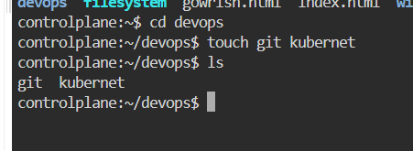
Step 8: cd devops and touch creates git and kubernet files.
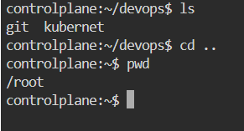
Step 9: pwd command shows the current working directory.
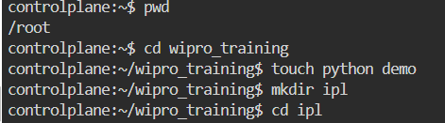
Step 10: touch and mkdir commands create files and folders inside wipro_training.
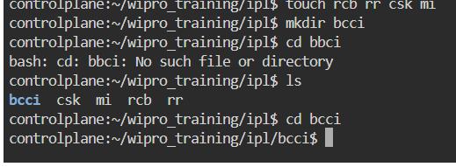
Step 11: touch creates multiple files (rcb, rr, csk, mi) and mkdir creates bcci folder. cd bcci moves into that folder.
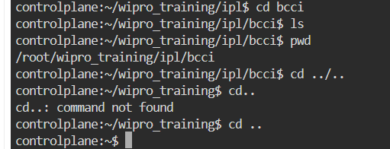
Step 12: ls and pwd show files and path. cd .. is used to move back to parent directory.

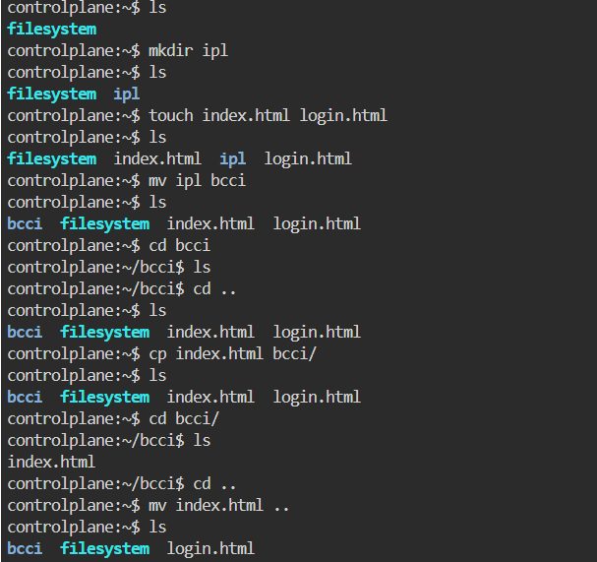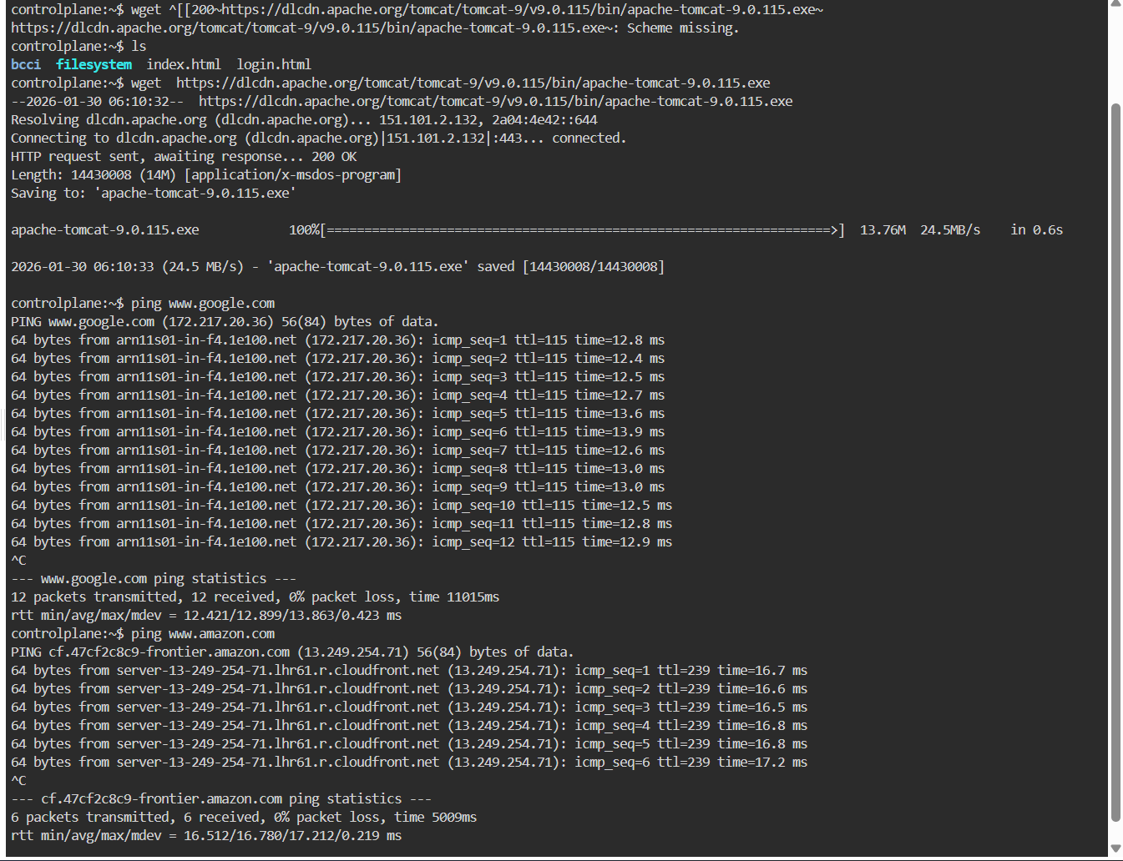
Step 13. Here we use cp command to add the files into the directories

Step 14. wget https://dlcdn.apache.org/tomcat/...exe
Downloads the Apache Tomcat installer file from the internet.
The file will be saved in the current directory.
ping www.google.com
Checks whether Google server is reachable from your system.
Used to test internet connectivity and network response.
ping www.amazon.com
Checks network connection between your system and Amazon server.
Shows packet response time and connectivity status.

